Milestone 2: Model Training and PPE Detection Evaluation Report

Introduction
The objective of this milestone was to train and evaluate an object detection model capable of identifying Personal Protective Equipment (PPE) such as helmets and safety vests in construction site images. The model was trained using the YOLOv8 architecture and the Construction Site Safety dataset.
The goal was to build a reliable detection system that can identify safety compliance violations in workplace environments.

Dataset Description
The dataset used for training contains annotated construction site images with bounding boxes indicating different PPE-related classes.

Dataset Structure
dataset/
├── images/
│ ├── train/
│ ├── val/
│ └── test/
├── labels/
│ ├── train/
│ ├── val/
│ └── test/
└── data.yaml

Dataset Split

Split | Images
Train | 1960
Validation | 560
Test | 281
Total | 2801

Each image has a corresponding label file in YOLO format: class_id x_center y_center width height
All bounding box values were normalized between 0 and 1.

Model Training Configuration
The YOLOv8 object detection model was used for training with pretrained weights.

Baseline Configuration

Parameter | Value
Model | YOLOv8n
Epochs | 50
Image Size | 640
Framework | Ultralytics YOLOv8
Hardware | Google Colab GPU (Tesla T4)

Training was performed using the command:

yolo detect train data=dataset/data.yaml model=yolov8n.pt epochs=50 imgsz=640

Model Performance Metrics

After training, the model was evaluated on the validation dataset.

Metric | Value
Precision | 0.784
Recall | 0.648
mAP@0.5 | 0.719
mAP@0.5:0.95 | 0.384

Interpretation
  - Precision measures how many detected objects were correct.

  - Recall measures how many actual objects were detected.

  - mAP@0.5 represents overall detection accuracy.

The model achieved a 71.9% detection accuracy, which indicates good performance for the initial training stage.

Hyperparameter Experiments
To improve model performance, additional experiments were conducted by modifying training parameters.

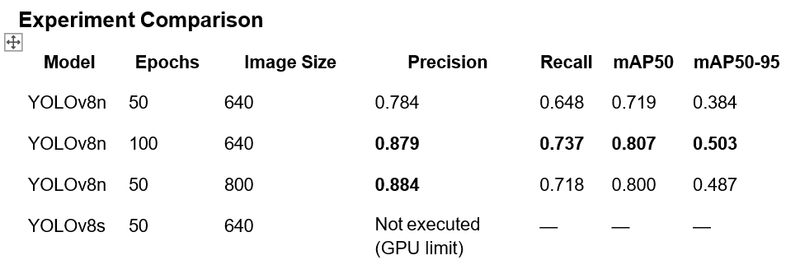
Observations
  - Increasing the number of training epochs significantly improved model performance.

  - Higher image resolution improved precision slightly.

  - Longer training allowed the model to learn better object representations.

Prediction Results
The trained model was tested on unseen images from the test dataset. The model successfully detected:
  - Helmets

  - Safety vests

  - Workers without PPE

Example detections include:

  - Correct detection of workers wearing helmets.

  - Detection of missing safety equipment.

  - Some missed detections in crowded scenes.

Prediction images were generated using:

yolo detect predict model=best.pt source=dataset/images/test

Error Analysis
During prediction analysis, several common challenges were observed:

  - Small helmets were sometimes missed.

  - Partial occlusion of PPE reduced detection accuracy.

  - Poor lighting conditions affected model confidence.

  - Overlapping workers sometimes caused incorrect bounding boxes.

These issues indicate the need for additional training data and augmentation.

Conclusion
The YOLOv8 model successfully detected PPE objects in construction site images with good accuracy.
The best configuration achieved:

Model: YOLOv8n Epochs: 100
Image Size: 640
mAP@0.5: 0.807

Increasing the number of training epochs provided the most significant improvement in detection performance.
Future improvements may include:

- using larger models such as YOLOv8s or YOLOv8m

- applying advanced data augmentation

- training on larger datasets.

Deliverables
The following outputs were generated during this milestone:

  - Trained YOLOv8 model (best.pt)

  - Training logs and performance metrics

  - Precision-Recall curves

  - Confusion matrix

  - Sample prediction images

  - Experiment comparison table

  - Evaluation report

result.png

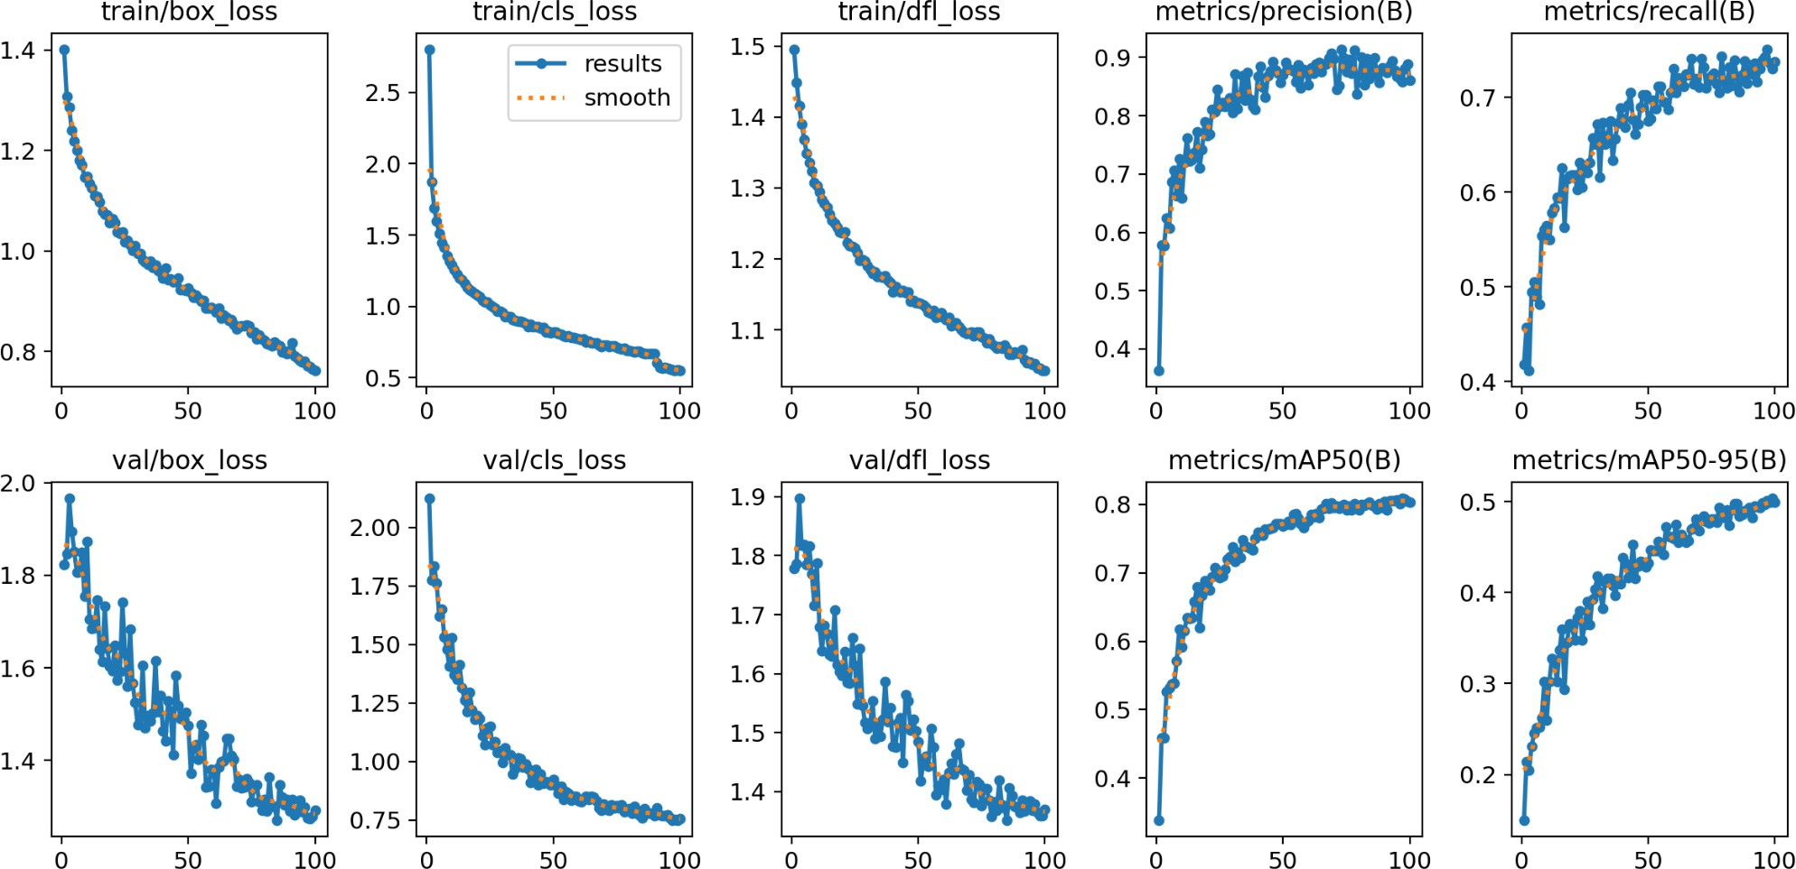

Confusion matrix
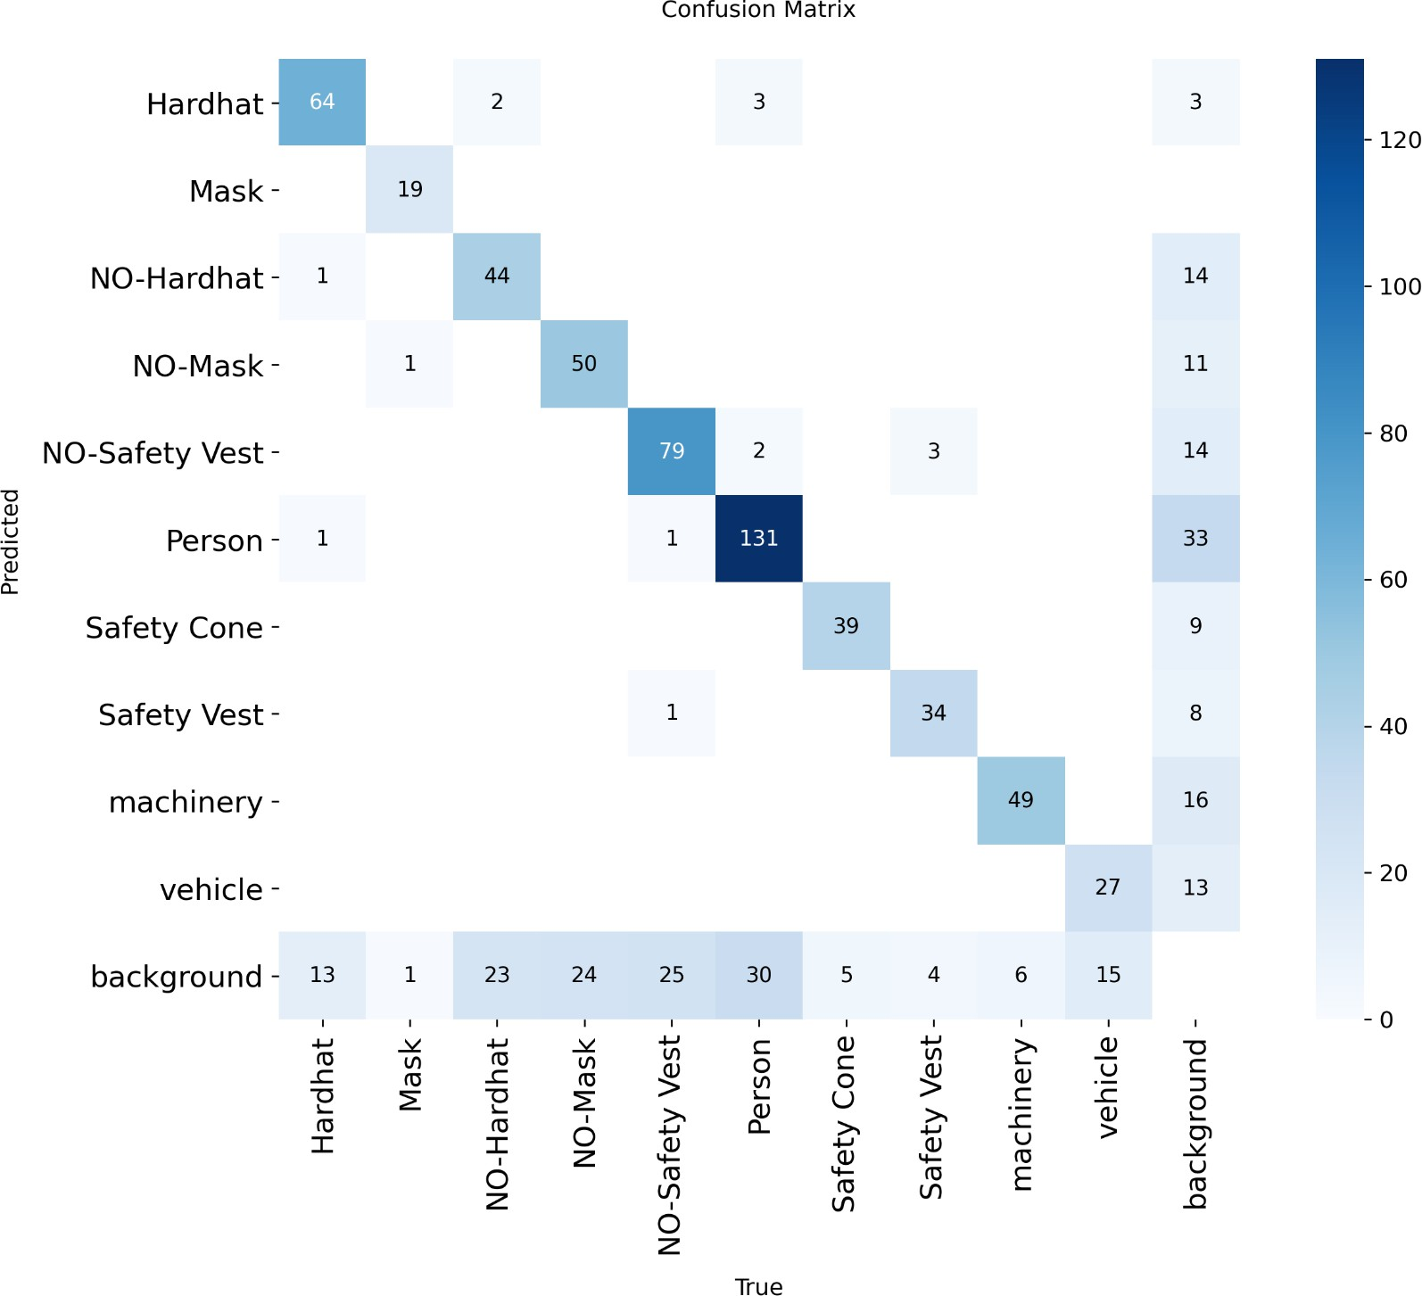

Prcurve.png
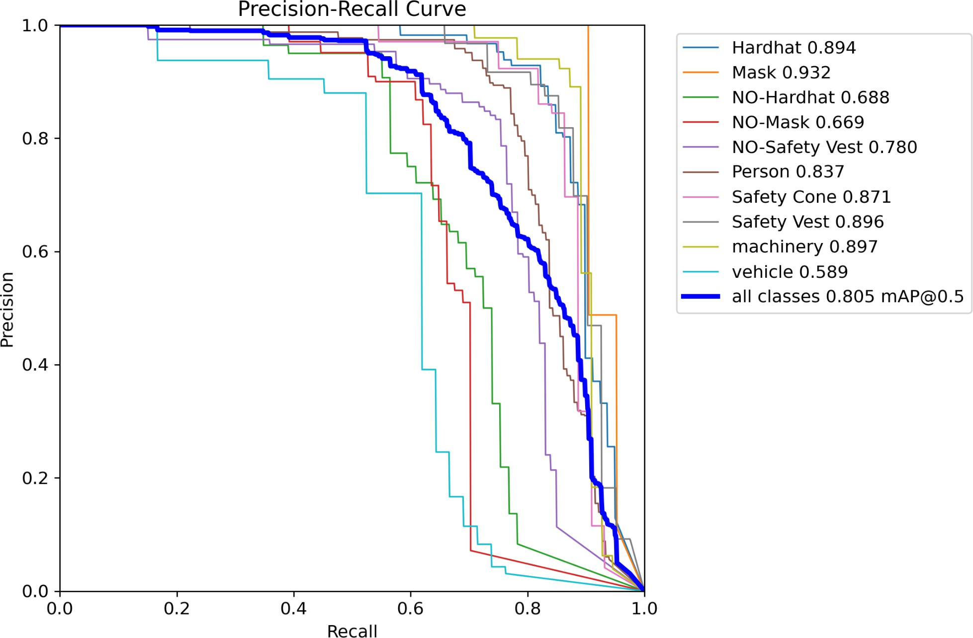

Predicted images
